**Comments from Nadine - Main Page and General Comments: *(Julie’s comments in red)***

1. The link for the Reference Guide works, but not for the Statistical Methodology Guide. This is the same for the French version. *Leaving this here so we don’t forget*
2. The link to Health Canada also does not work. *Leaving this here so we don’t forget*

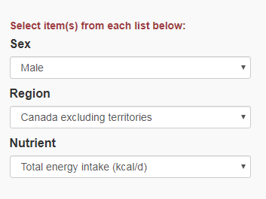

1. Suggestion for above screenshot: I would take off the ‘s’ from item because you can only select one item from each drop down anyways, or you could say “specify criteria below”. I noticed in French it says specify the parameters, so maybe could also say “specify parameters below”?
2. The parameters in the drop down menus are in alphabetical order in French but not in English, I would make it consistent between the two.

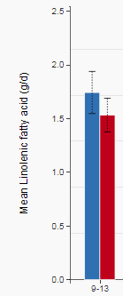

1. The titles for the y axis seem to have both first words consistently capitalized, only the first word should be capitalized (screenshot above). This is the same in French. *Leaving this here as a reminder for whenever we finally settle on the axis title*
2. Under the graphs the title corresponding to the age groups in French says Âge (en années), it should say “Groupes d’âge (ans)”. This should aslo be changed in the column header in the table and when you hover over a bar and the details are shown.
3. Also under the graphs where it says “Les barres d’erreur représentent l’intervalle de confiance à 95%”, there is a space between the 95 and % sign that needs to be removed.
4. In English, both the “save chart” and “download table” buttons function properly, however

I noticed in the downloaded table that the age range 9-13 was converted to a date (details in screenshot below).

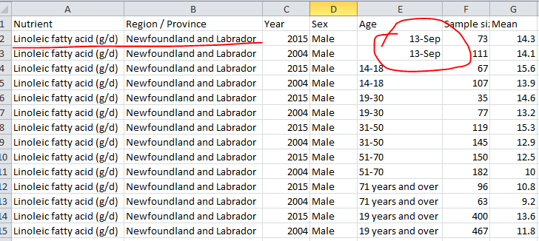

1. In French, both buttons also function properly, however, in the downloaded excel spreadsheet, French letters with accents get converted to symbols (screenshot below).

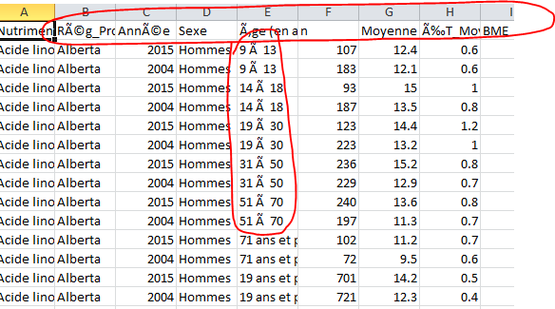

1. When you sort by age, the 9-13 age category gets placed at the end of the list instead of remaining before the 14-18 category and the 19 years and over category also moves up instead of staying at the end (screenshot below).

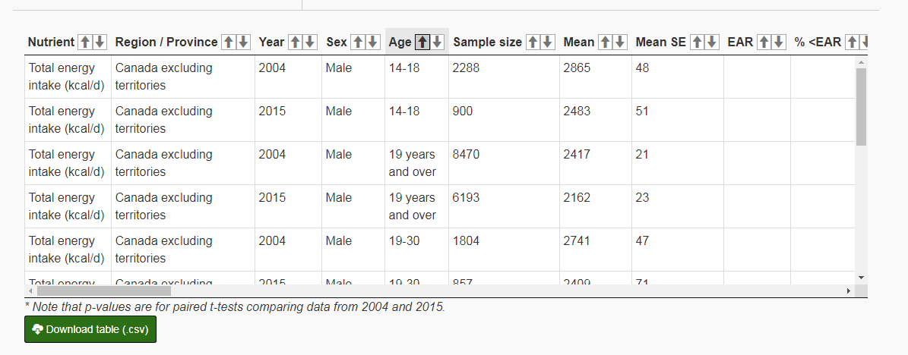

1. Once you filter by year, it would be nice to be able to reset the view to see the 2004 and 2015 corresponding pairs but you can’t as all the 2004 and 2015 values remain separated, you would have to refresh the page and re-specify the criteria you want to look at (screenshot below).

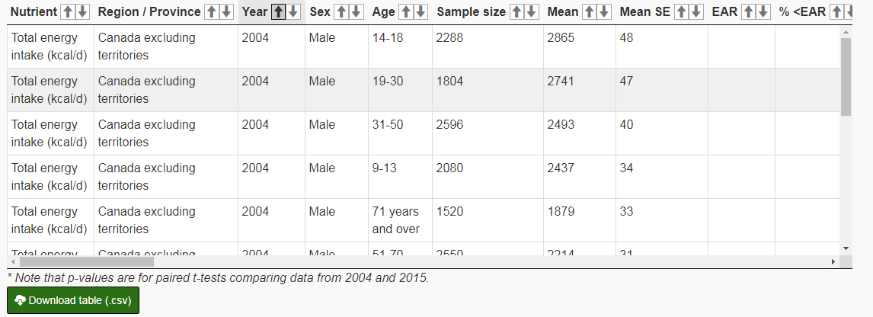

1. The spacing in the online nutrient tables is nicer in most of the French versions than in the English ones, the rows are more narrow. See example below.

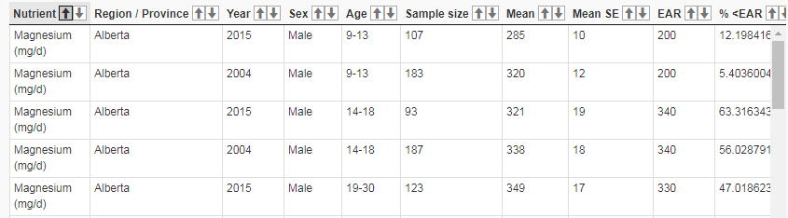

**Vs**

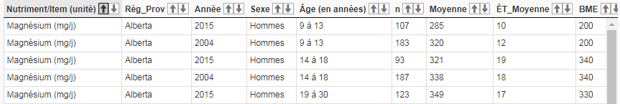

This is the opposite however for Moisture/Eau totale for males in Canada excl. territories. The FR

one is wider than the EN. Did not see if there were any other cases since I was not always focused

on all the tables.

1. The ‘Symbol Legend’ does not include a definition for AMDR (screenshot below).
   1. AMDR: Acceptable Macronutrient Distribution Range
   2. ÉVAM: Étendue des valeurs acceptables pour les macronutriments
2. I don’t know how much work this is but just a suggestion, would it be possible to have the ‘Symbol Legend’ included in the csv download as a separate sheet? I don’t think this is essential, but might be a nice to have feature so that when someone downloads the file they don’t have to necessarily go back to the webpage to see what the acronyms are.
3. When switching between English and French, it resets the entire page and you have to re-specify the criteria that you were looking at. Not sure if this is how it needs to be setup because of coding/programming or if it’s possible to translate and maintain the specified criteria?
4. You know how when you hover on the bars the info appears on the left, for the striped bars, I think it might be worthwhile to add “interpret with caution” on the left side under the data.

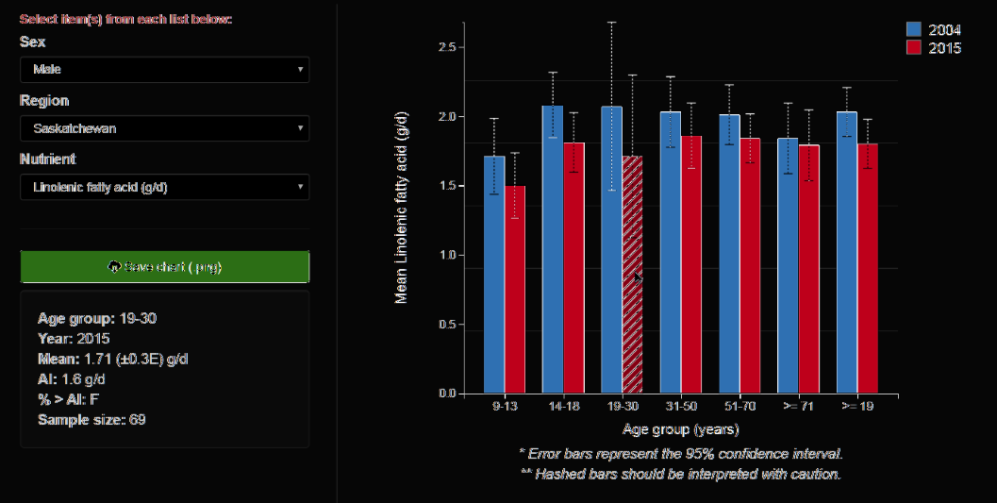

1. This is probably super extra, but it would be nice to see the path of how to get to this page under the generic gov of Canada banner. I copied an example below from the InfoBase designed for the Canadian Chronic Disease Surveillance System.

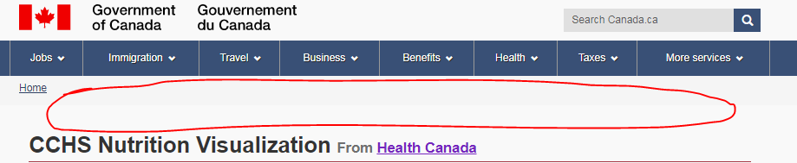

**Example:**



1. Already discussed the amount of decimal places for some of the values with Julie.

**Comments for Specific Nutrients**:

- Add the word total to Apport énergétique… it should read “Apport énergétique total (kcal/j)”

-Linolenic fatty acid (g/d) should read “Linolenic acid (g/d)” (delete fatty)

-Linoleic fatty acid (g/d) should read “Linoleic acid (g/d)” (delete fatty)

- Mean % of total energy intake from **linolenic ~~fatty~~ acid (delete fatty, add acid).** Same for drop down.

- Mean % of total energy intake from **linoleic ~~fatty~~ acid (delete fatty, add acid).** Same for drop down.

- Total polyunsaturated fats should be “Total polyunsaturated fatty acids”.

**\*also if I made any corrections to nutrient names I did not include the units, but just a reminder to keep the units as is, I just didn’t incorporate them into my corrections.**

**Comments from Julie:**

* Since the units are included in the axis title, I think we could omit them from the titles if this isn’t too much work to implement.
* Can we visually represent the hashed bars rather than using words in a text box? And can this be made to only appear instances when there are in fact hashed bars on the graph? (I assume this 2nd ask is too much)
  + Interpret with caution
  + If we have to stick with text description, these were Nadine’s comments: Under each of the graphs where it says “hashed bars should be interpreted with caution” I would say “striped bars” or “bars with a striped pattern” should be interpreted with caution. It seems that they are also referred to as “hatched bars” online. If striped is chosen, in French you could say “Les barres avec bandes diagonales **devraient être (instead of doivent)** interprétées avec prudence”.
* All figure titles, axis titles, table titles – only the first word or proper nouns should be capitalized throughout. Words following a: can be capitalized as well.
* Can the “Data Source: Statistics Canada …” text be moved to be contained within the graph so that when people download the file it is included? [See the Chronic Disease tool](https://health-infobase.canada.ca/ccdss/data-tool/)
* In the Notes and Legend it should read: UL : Tolerable Upper Intake Level